PROTECTION AND PERMANENCY M EMORANDUM, 13-11

TO: Service Region Administrators
Service Region Administrator Associates
Service Region Clinical Associates
Regional Program Specialists
Family Services Office Supervisors

FROM: Tina Webb, Assistant Director
Division of Protection and Permanency

DATE: August 26, 2013

SUBJECT: Updated DPP-1292 Information for OOHC Placements

TWIST was recently modified, at the commissioner’s request, to require billing specialists to enter additional information in out of home care cases. When a suitable relative is identified as a placement for a child, but the relative declines due to financial reasons, based on the lack of kinship care or lack of child care assistance, the billing specialist must complete the information in the red box below.
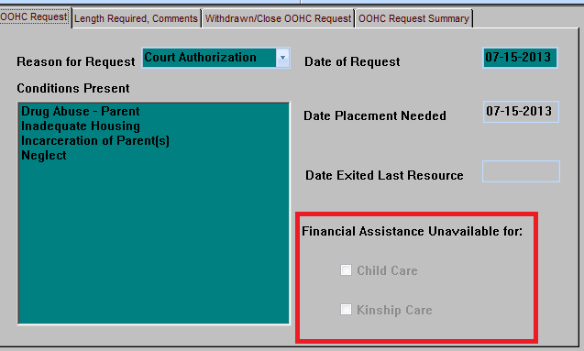

Content has been added to the DPP-1292 Information for OOHC Placements to ensure that this information is relayed to the billing specialists at the time of placement.

Content has also been added to the DPP-1292 regarding what type of documentation should be included, with the form, when a relative case is being closed, but the judge will not provide a court order or grant permanent custody.

Staff should begin using the updated form immediately.

If you have any questions regarding this memorandum, please contact gretchen.marshall@ky.gov via e-mail, or by telephone at (502) 564-7635, ext. 3587.

